MEMORANDUM

To: Joanna Rycerz

2nd September 2021

Warsaw, Masovian District, Poland

Q: What type of hashing algorithm was used to protect passwords?

A: **MD5** or **MD4** (Raw Hash)

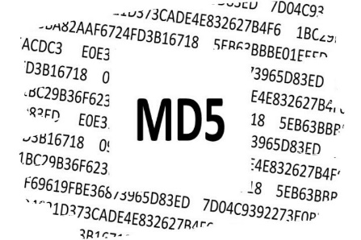

Q: What level of protection does the mechanism offer for passwords?

A:

* MD5 is an “**iterative**” hash function.
* MD5 is generally a **considerable mechanism** for storing passwords in production.
* MD5, produces a **128-bit hash.**
* MD5 is born out of **RSA’s algorithm** (defined in Internet RFC).
* MD5 is a utility that can **generate a digital signature of a file**. MD5 belongs to a family of one-way hash functions called **message digest algorithms**. The MD5 system is **defined in RFC 1321**.
* The algorithm takes as input a message of **arbitrary length** and produces as output a **128-bit "fingerprint" or "message digest"** of the input. It is conjectured that it is **computationally infeasible** to produce two messages having the same message digest, or to produce any message having a given prespecified target message digest. The MD5 algorithm is **intended for digital signature applications**, where a large file must be **"compressed"** in a secure manner before being encrypted with a private (secret) key under a public-key cryptosystem such as **RSA**.

Q: What controls could be implemented to make cracking much harder for the hacker in the event of a password database leaking again?

A:

* One way of making the password hard to crack is by **maintaining credentials from multitude of services in a manager** like dashlane because they tend to use **varied hashing** algorithms & even hashing over hashed passwords [e.g. md5(md5($plaintext)) ] to store and keep the **strength high**, meeting to the rigidity of a strong case for an algorithm to process.
* **Reduce redundancy** across services such that in case of a leak out of one service doesn’t make the **other passwords vulnerable**.
* **Use alphanumeric character** with **special characters**.
* Reducing occurrence of an **adjective on noun or verb** which is an obvious prey to brute force attacks.

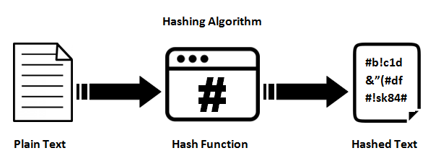

Q: What can you tell about the organization’s password policy (e.g. password length, key space, etc.)?

A: It can be very well determined that the organization's **password policy is not up to the mark** as:

* The key length is at an **average of 11**.
* Although they do not allow spaces, the use of **special characters is probably resisted** to a set of common delimiters like ‘_’.
* The use of **numbers increases the resistance** of password by a factor of **10 times the digit appears**.
* The **lack of capital characters** splits the password strength by half.
* **Not avoiding the occurrence of English verbs** like book, popular, eating, hero, life, John Wick, interest, expert in turn making the password vulnerable to brute force attacks.



Q: What would you change in the password policy to make breaking the passwords harder?

A:

* Keeping a **threshold on length**.
* **Caution** over use of **verbs are nouns or adjectives**.
* **Mandating** minimum **3 special characters and minimum one capital letter**.
* Applying a **hashing algorithm over another**, recursively to have a strong hashing function e.g. md5(strtoupper(md5($plaintext)))
* **Not allowing sibling credentials** **to assist** the password naming, like name / surname / date of birth / sex.

